**Movie Search Application**

**Name= Amit Babu Khatri**

**Student id=** [**np03cs4s230291@heraldcollege.edu.np**](mailto:np03cs4s230291@heraldcollege.edu.np)

**HTML CODE:**

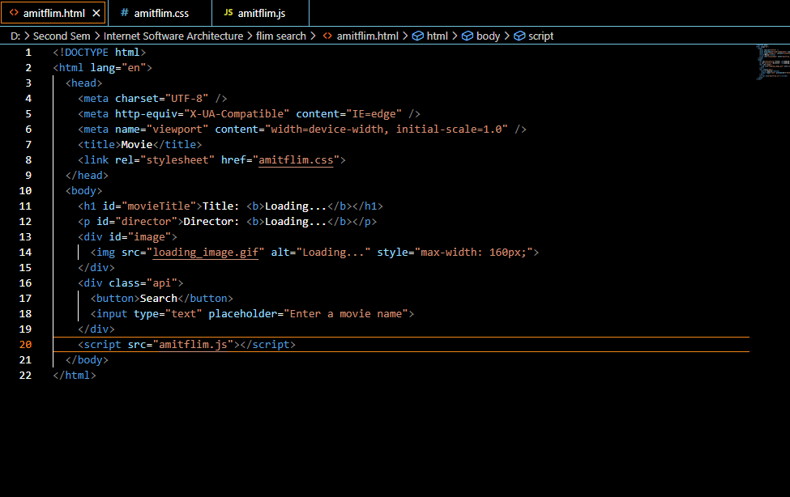

**CSS CODE:**

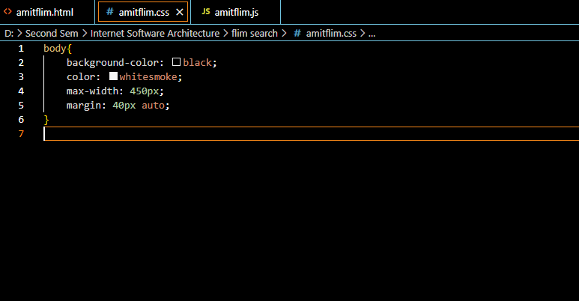

**JAVA SCRIPT CODE:**

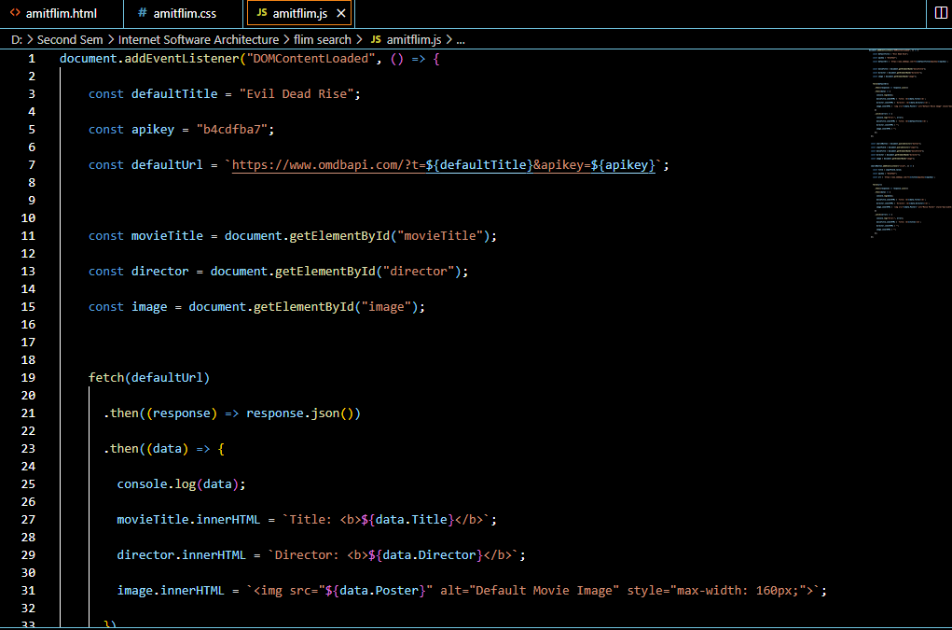

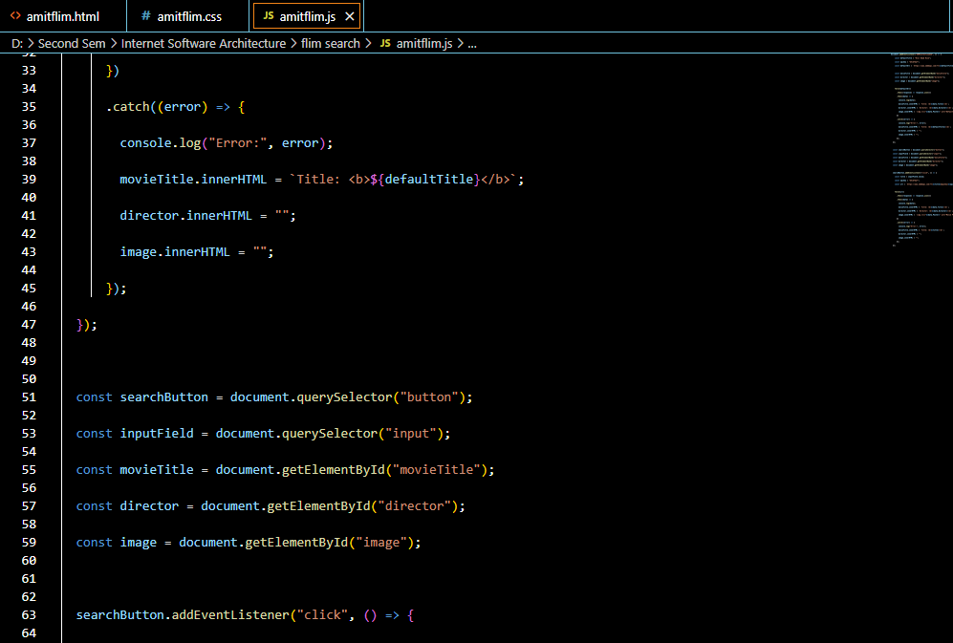

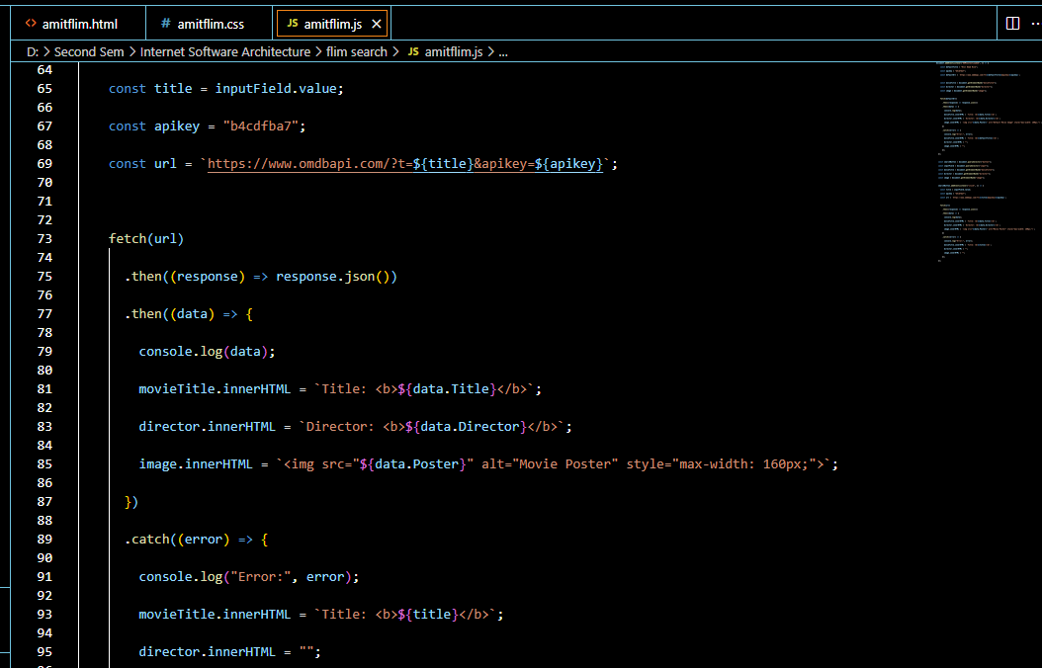

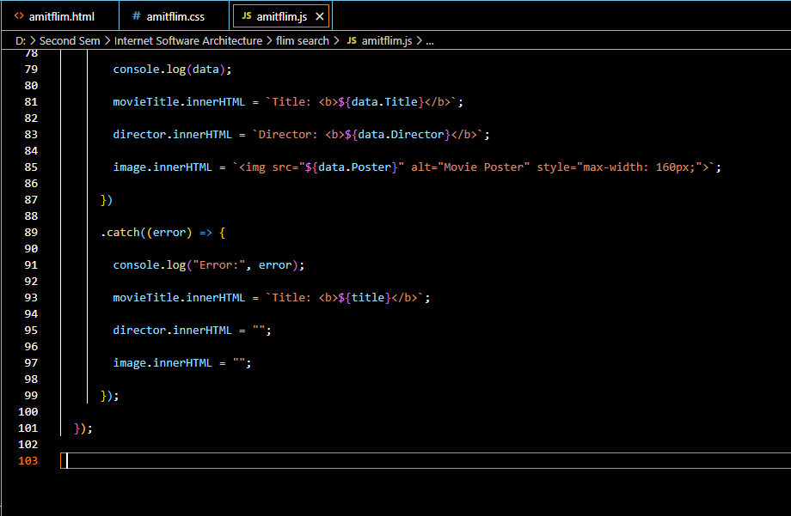

**RUNNING AND DEBUGGING OF CODE:**

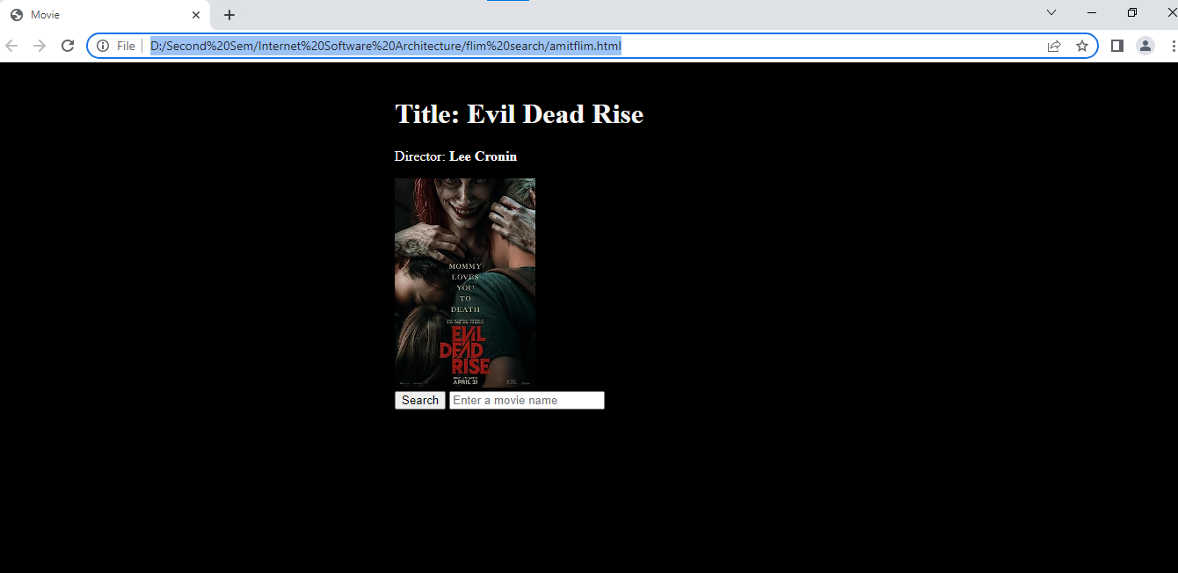

**CONCLUSION:**

Overall, this code sets up a basic implementation for movie search application using HTML, CSS, and JavaScript. User can search the movie by clicking the corresponding button. The code keep track to all the movie including image tittle and name of director.

**From this code, we can learn about the following concepts:**

1.HTML structure and elements.

2.CSS styling and responsive design.

3.JavaScript event handling and DOM manipulation.

4.Implementing game logic using JavaScript functions.

5.Using variables to store and update game data.

6.Reloading the page using JavaScript.